Image | 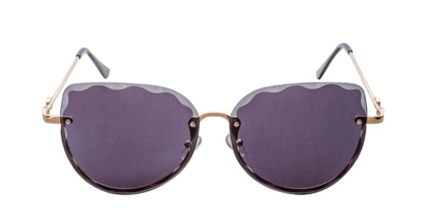
Brand | PRADA
Model Name | Dodger FSG
Price | RS 1800
PRODUCT DETAILS

